Use Cases Description
UC7- Email Management

For

Meeting Room
Booking System
(MRBS)

Prepared by K15T1-Team11
Van Lang University
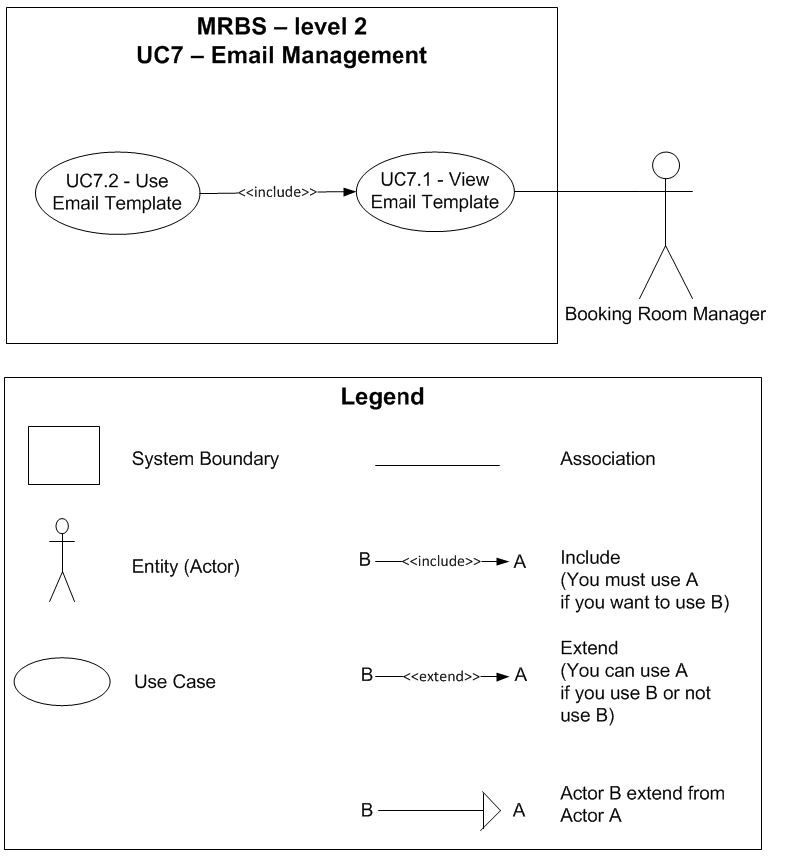

Table of Contents
UC7.1 – View Email Template 4
UC7.2 – Use Email Template 4

UC7.1 – View Email Template
ID | UC7.1
Name | View Email Template
Author | Tam Do | Modify by | Tam Do
Date | 06/29/12 | Update | 07/12/12
Actor | Booking Room Manager
Description | User can view a detail email template information
Precondition | User signed in system by Booking Room Manager’s account
Post condition: | System show a detail email template information that user choose
Main flow: | 1. User press “Danh mục”  2. User choose “Quản lý email”  3. System show new dialog “Quản lý email”  4. User press “Tên mẫu” combobox  5. User choose an email template that want to view  6. System show a detail email template information that user choose
Alternative flow:
Exception :
Includes:
Priority: | Low
Business rules:
Mockup screen

UC7.2 – Use Email Template
ID | UC7.2
Name | Use Email Template
Author | Tam Do | Modify by | Tam Do
Date | 06/29/12 | Update | 07/12/12
Actor | Booking Room Manager
Description | User can apply to use an email template information or not
Precondition | User signed in system by Booking Room Manager’s account  User staying at “Quản lý email” form and viewing a detail email template information
Post condition: | System save into database
Main flow: | 1. User click checkbox “Áp dụng mẫu này”  2. System save into database
Alternative flow:
Exception :
Includes:
Priority: | Low
Business rules:
Mockup screen

